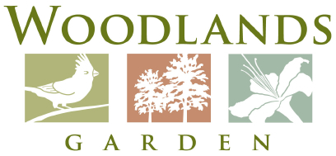

2015 Youth Art Market General Information
Woodlands Garden invites you to our 2nd Annual Youth Artist Market. This one-day arts event is for kids in grades 2 - 12 to create and sell their own artwork and crafts. The festival will be held in the meadow at Woodlands Garden on April 25th from 11am - 3pm. Rain date will be Saturday May 2nd.
Fees:
The deadline to register for the Market is April 3rd, 2015. The booth rental fee is $10 per 10’ x 10’ area. You may share a space with friends. Woodlands will assign booth locations (up to 30 spots.) Pay online at www.woodlandsgarden.org or mail a check to Woodlands Garden, P O Box 27, Decatur GA 30031. Please put YAM in the notes field online or on the memo line of your check.
Set Up:
Set up starts at 9:30 am. Please drop off your materials and leave by 10:45 to park off-site. (We will reserve offsite parking nearby for our artists.) Feel free bring tables, chairs and tents to present your artwork. After the event, you may pack up your materials and stage for pickup along the driveway.
If there is inclement weather, the event will move to the Overlook rooms inside the office building.
Other:
All proceeds from art sales go to YOU so bring change and a calculator!
We would like to include photos of you and/or your artwork in our publicity for the market. By April 3rd, please email photos to Claire@woodlandsgarden.org. Include a parent or guardian’s permission if you send pictures of yourself.
For questions please contact: Claire Hayes, Woodlands Executive Director at Claire@woodlandsgarden.org or 404-373-2222.
Thank you for your interest in Woodlands Garden’s Youth Art Market. We can’t wait to see what you create!

