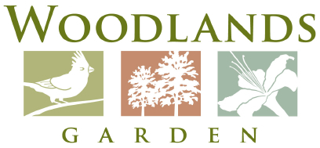
2015 Youth Art Market Application
Due WITH $10 BOOTH FEE by April 3rd, 2015
___________________________________________________________ _____________________________
Artist Name/Group Grade/Affiliation
___________________________________________________________ ____________________________
Address City State Zip
___________________________________________________________ _____________________________
Parent/Guardian Name School or Art affiliation
___________________________________________________________ _____________________________
Daytime Phone Number E-mail
Type of Media (circle):
3D Mixed Media 2D Mixed Media

Clay (functional) Clay (non-functional)

Digital Art Drawing (includes pastels)

Fiber (also dolls, baskets, leather) Jewelry (non metal)
Jewelry (metal) Painting

Photography Printmaking
Sculpture Wood

Other:

(YAM will not accept items from a kit and/or art made with licensed, trademarked, or copyrighted characters.)
Artist Statement:
Write a short statement on the back (or in an email) of 20 words or less describing your technique:

